LAB REPORT

CSE – 4508

Name : Abdullah

ID : 200041126

Lab Group : 1B

Submitted on : 17th August, 2023

Submitted to : MD. SHIHAB SHAHRIAR SIR

During today's laboratory session, we acquired proficiency in employing the SQL Loader utility to transfer data from a text file into an Oracle table. This utility seamlessly accommodates text files in formats such as .txt and .csv. Our focus for this session was on loading data from a .csv file.

The subsequent steps elucidate the process of directly loading data from a CSV file into the database.

Top of Form

Bottom of Form

**Procedure to input data:**

* First, when we look at the CSV file, we notice that the data is separated by commas. Each line represents one thing and is finished with a space.

Inside each line, there are four separate pieces of information separated by commas. These pieces of information are the ID, Name, Address, and Salary of the employees. Because of this, the table we create in the database needs four columns. These columns should be for Integer, varchar2, varchar2, and number data types, in that order.

Top of Form

Bottom of Form

* Next on the basis of gathered information the table should be created in the database after the user logs in into the database. 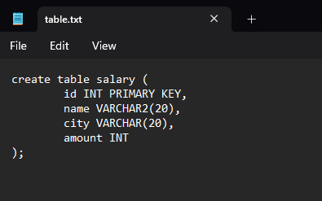
* Create a control file (.ctl) in any directory, preferably in the same location as the CSV file. Name the control file appropriately and open it using a text editor like Notepad.
* We are opening it using PowerShell command.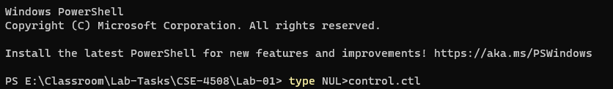

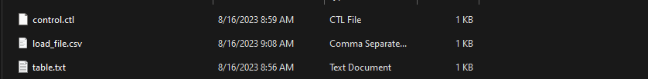

* After the blank file is opened, the following lines of code should be written in the .ctl file and saved.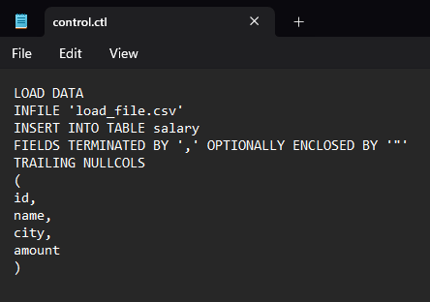
* Afterward, we enter the SQLLoader prompt, connecting it to the relevant control file and log file as shown below. At this stage, the user's credentials and the control file are supplied. Additionally, a custom log file is needed, allowing the option to select a preferred name. This process concludes with the database being updated using the provided values, as demonstrated in the accompanying visual reference.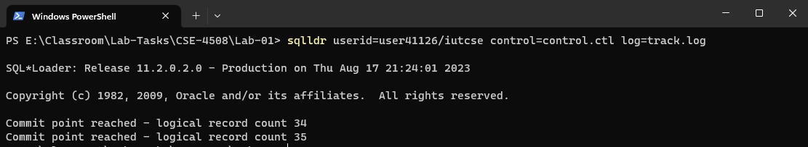
* This is the current condition of the file directory 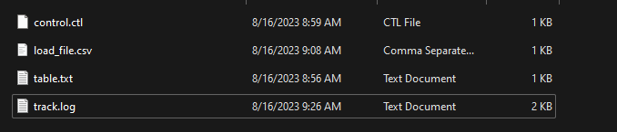
* We can check the track.log file now

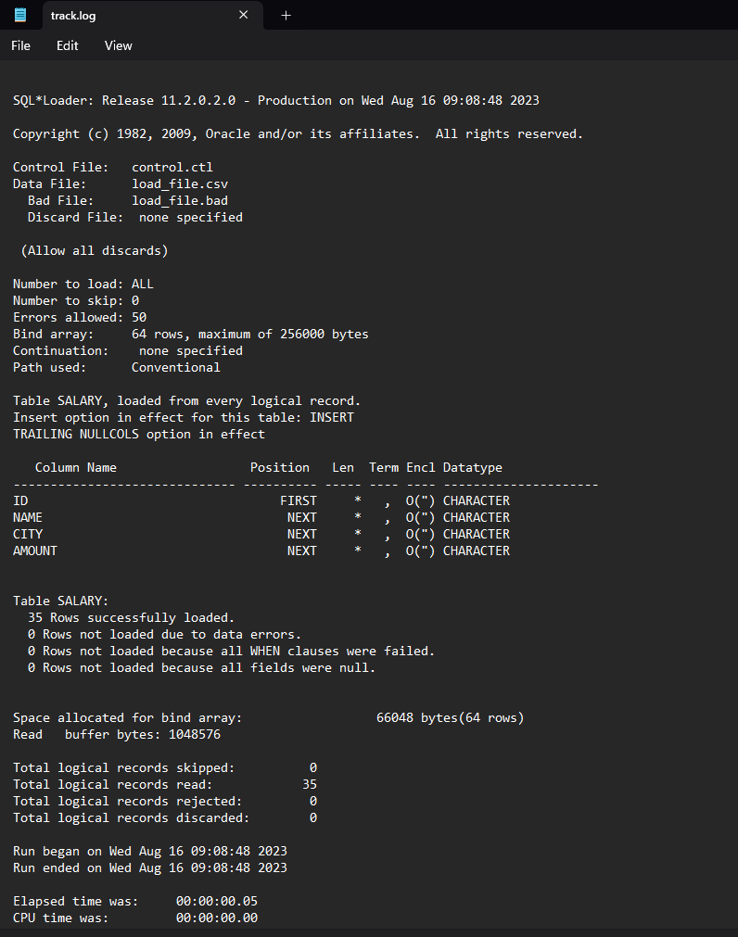

* Now, if we enter the database and select the table, the contents of .csv file will be displayed there.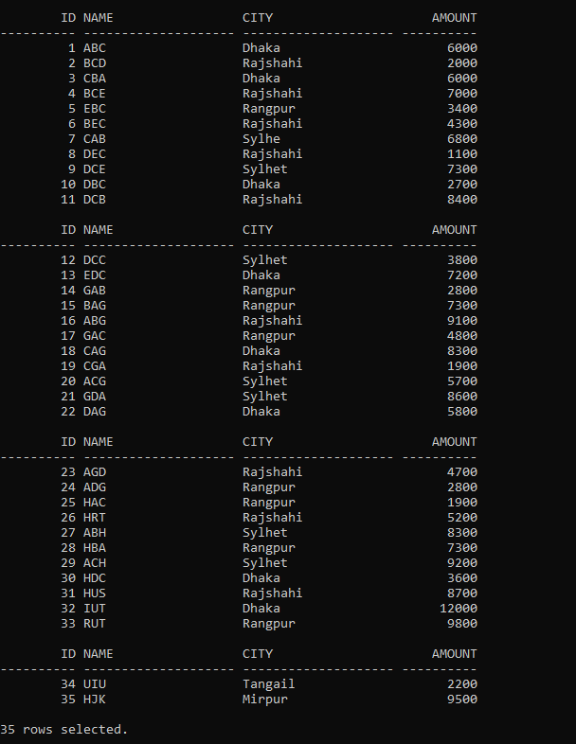

This depicts the method by which data is brought into the database from a .csv file, and sqlldr automatically handles any errors using suitable control file directives.